Representation One:

I shall easily show that it is impossible to tax further, ruinous to be always borrowing and not enough to confine ourselves to measure of economy, and that, with matters as they are, ordinary ways are unable to lend us to our goal, and the only effective remedy, the only means of finally putting the finances truly in order, must consist in reviving the entire State by recasting all that is unsound in its constitution(1). I shall show the disparity(2), discord and incoherence of the various parts of the body of the monarchy result from the constitutional defects that sap its strength and impede(3) its functioning; that we cannot eliminate any one of them without attacking them all in the primary factor which caused them originally and still perpetuates(4) them; that this (factor) alone infects everything, harms everything and prevents any improvement; that a kingdom composed of pays d’état… a kingdom whose provinces are foreign one to another; where multiple internal frontiers separate and divide the subjects of the same sovereign, where certain regions are totally freed from taxes, the full weight of which is borne by other regions; where the richest class is the least taxed; where privilege prevents all stability; where neither a constant rule nor a common will is possible—such a state is inevitability a very imperfect kingdom, full of corrupt practices and impossible to govern well. In effect, the result is that general administration is excessively complicated, public contributions unequally spread, trade hindered by countless restrictions… agriculture crushed by overwhelming burdens; the state’s finances impoverished by excessive costs of recovery and by variations in their yield.

Finance Minister Calonne’s criticisms of the state of France’s economy, April 1787.

(1) constitution = in this context, the state of France
(2) disparity = difference; inequality
(3) impede = prevent; hold back
(4) perpetuates = continues

a. Identify two problems in the taxation system of France outlined by Calonne:

i. Some regions were exempt from tax while other bore the full weight of them.

ii. Corrupt tax collection methods.
2 marks

b. Identify two other problems outlined by Calonne (not referred to in your response to question a):

i. Excessive loans.

ii. Finances impoverished by excessive costs of recovery.
2 marks

c. By quoting from the representation, and using your own knowledge, explain the state and causes of France’s financial situation on the eve of the Revolution.

In February 1781, Necker’s Compte Rendu revealed the financial accounts of the French government for the first time in order to raise faultering confidence and further loans, ultimately adding to the already fragile state of Frances finances. Firstly, France’s involvement in the Seven Years War (1756-63) and American War of Independence (1778-1783) had cost the government over 1 billion livre, for which Necker was able to raise a further 520 million livres in loans. Following Neckers departure, De Fleury raised a further 252 million livres between 1781-1783, while seeking to renovate the already extravagant residencies of King Louis XVI. This left Calonne with the onerous task of recommending major financial reforms that would bring Frances “finances truly in order” between 1783 and 1787. By 20 August 1786, Calonne informed Louis of the impending bankruptcy, while also failing to convince his enemies in the Assembly of Notables (1787) for the need to reform by the “richest class”. By August 1788, Brienne was forced to proclaim France bankrupt and call for the meeting of the Estates General the following year. (178 words)
6 marks

d. Evaluate to what extent this representation is useful in explaining the range of problems that contributed to a revolutionary situation in France by 1789. Refer to other views in your response.

The representation effectively addresses the financial situation that led to a revolutionary situation in France by 1789. It acknowledges the role of the the taxation system, the momentous cost of foreign policy, the illogical restrictions placed on trade and the lack of uniformity in the provinces that generated a revolutionary situation among the 3rd Estate, who were paying 80% of their income on bread. However, while Calonne does refer to France’s outdated agriculture, he does not highlight the failed harvests of 1783, nor could it predict the disastrous hail storm of 1783 that lead to the bread crisis. It also does not highlight the political factors that followed Calonne’s complaints such as resistance to reform from the Assembly of Notables in March, and Paris Parlements in July, 1787. Furthermore, it cannot explain Louis XVI’s failure to provide leadership at the Assembly, Parlements or the Estates General of 1787 and 1789. Marxist historians such as Lefebvre would challenge this source, claiming that, despite financial problems “The ultimate cause of the revolution was the rise of the Bourgeois.” However, revisionist Simon Schama would support Calonne’s view of inequality as “It was in the Church, more than any other group in France, that the separation between rich and poor was most bitterly articulated.”However, post revisionist Gwynne Lewis criticized revisionist interpretations as they tend to “downplay the importance of social causes of the revolution.” (226 words)

10 marks

Representation Two:

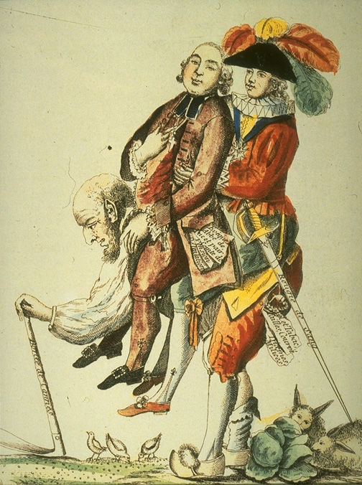

Burden of the Third Estate

a. Identify the two figures sitting on the man in this representation:

i. King Louis XVI

ii. A Noble of the Sword
2 marks

b. Identify the man on the bottom of the other two men and two ways we know this:

i. Member of the third estate, he is bent over and carrying a farming tool, suggesting he is a peasant

ii. Member of the third estate, surrounded by birds and rabbits that he cannot hunt.
2 marks

c. By referring to the representation, and using your own knowledge, explain how the range of burdens placed on the Third Estate led to a revolutionary situation in France.

The Third Estate, particularly the peasantry, were burdened with taxation and feudal obligations. Leading towards the revolution of 1789, the Third Estate were forced to pay variety of taxes, one being the Capitation, a population tax, the second the Corvee, a form of forced feudal labour - which is seen protruding from the pocket of the noble - and the third, the Vingtieme, a tax introduced in war time, taking one twentieth of a citizens income. The Vingtieme was significant in generating a revolutionary sentiment as it was introduced to cover the debts generated by the War of Austrian Succession (1740-48). The continuation of this tax through the Seven Years War (1756 - 1763) and the American War of Independence (1778 - 1783). While intended as a tax on all orders, its collection was typified by corrupt tax farming techniques that saw the 1st and 2nd Estate avoid payment, with the burden falling on the 3rd Estate, generating public anger at taxation methods.

Things to consider:

159 words.

The answer included a reference to the source – “the Corvee, a form of forced feudal labour - which is seen protruding from the pocket of the noble”

The answer considered a range of burdens: The Corvee, Vingtieme and Capitation tax.

The answer made links between French foreign policy and the impact of the relevant tax:
“While intended as a tax on all orders, its collection was typified by corrupt tax farming techniques that saw the 1st and 2nd Estate avoid payment, with the burden falling on the 3rd Estate”

The answers are SIGNPOSTED: “The first…. the second…. the third….” This allows the reader to break up your argument and see its different parts.

6 marks

d. Evaluate to what extent this representation presents a reliable view of the range of grievances in France of the ancien regime up to 1789. Refer to other views in your response

The representation provides a limited view of the range of grievances that existed in France, prior to revolution. What is obvious is the burden experienced by the peasantry during the Ancien Regime. With the 1st and 2nd Estates avoiding payment of taxes such as the taille, a land tax which only the 3rd Estate paid, the image presents the view that the peasantry ‘carried’ the burden of the excesses of the Crown and the Nobility in royal expenses and seigniorial privilege. The peasantry, burdened by the culture of deference, were prevented from hunting on a Lord’s land, allowing protected animals to destroy their subsistence farms. The image highlights the crisis created by the crippling food shortages and poor harvests of 1788. The Marxist perspective reflects a simplistic interpretation of this image as Soboul stated these burdens created the desire to “destroy aristocratic privilege”. However, it says little of the wealth that existed within the bourgeoisie, the liberal intentions of the nobility and the divisions that plagued the 1st Estate. As Schama points out; “It was in the Church, that the separation between rich and poor was most bitterly articulated.” Abbe Seyies, in his pamphlet “What is the Third Estate” reflected the recognition of France’s economic failings felt in the lower clergy. Leading toward the Estates General, all three Estates were invited to present their grievances. 89% of the Nobility were surprisingly, willing to forgo their privileges in the name of reform. The image therefore, does not reflect the complexity of cahirs that created revolutionary sentiment in France, up to 1789.

260 Words

Things to consider:

The response points out the strengths of the image: “the image presents the view that the peasantry ‘carried’ the burden of the excesses of the Crown and the Nobility in royal expenses and seigniorial privilege”

The response points out the limitations of the image: “However, it says little of the wealth that existed within the bourgeoisie, the liberal intentions of the nobility and the divisions that plagued the 1st Estate”.

The response makes limited quotes of historians (they don’t need to be long!): “as Soboul stated these burdens created the desire to “destroy aristocratic privilege”

The response demonstrates a complex understanding of the nature of each estate

The response is able to incorporate statistics, dates and names

10 marks

Year 12 History: Revolutions
Unit 3: France

AOS 1: Movements, Ideas, Leaders and Events

1 | Knowledge of a range events and factors which developed during the course of the revolution.
2 | Identification and analysis of the causes of tensions and conflicts generated in the old regime that contributed to its breakdown.
3 | Analysis of the importance of ideas, ideologies, individuals and groups in bringing about revolutionary change.
4 | Analysis and evaluation of evidence that synthesises a range of visual and written sources.
5 | Analysis and evaluation of historians’ interpretations.

Comments:

Band:

Very Good Good Satisfactory Borderline Poor

